### [**VW Love Bug Ornament for the Christmas Tree**](https://papercraftetc.blogspot.com/2018/12/vw-love-bug-ornament-for-christmas-tree.html)

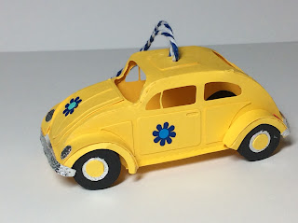

VW Love Bug Christmas Ornament with a string hangar on top.

I made a VW Love Bug for my Christmas tree. This three inch model reminds me of the time that a friend drove me in his VW Bug with a hole in the floor on the passenger side. The hole was so big that I could see the pavement speeding by at 50 mph. It was a wild ride!  
  
The curved tire well pieces are a little hard to put together. I recommend curving all the pieces to their final form and then gluing them tab by tab. It is a little tedious but it works.  
  
I used cardstock for the model and shiny vinyl for the peace flowers.

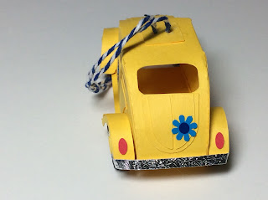

The bumpers are glued on just the ends

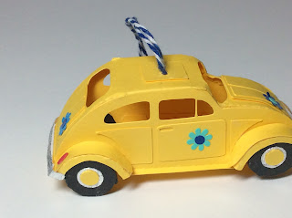

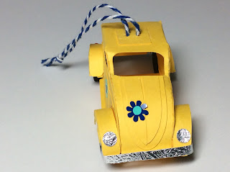

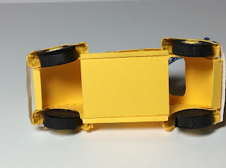

undercarriage



Prototype without the string hangar